Table of Contents
1. Predicting House Prices: 2
Summary / Observations: 2
2. Document retrieval from Wikipedia data 3
Summary / Observations: 3
• Experimenting with LSH implementation¶ 4
• Quality metrics for neighbours¶ 5
• Clustering text data with Gaussian mixtures 5
• Modeling text topics with Latent Dirichlet Allocation 5
• Modeling text data with a hierarchy of clusters 7
3. Recommending Songs: 8
Summary / Observations: 8
4. Deep features for Image retrieval nearest neighbour search 8
Summary / Observations: 8
5. Predicting sentiment from product reviews 8
Summary / Observations: 8
6. Identifying safe loans with decision trees 9
Summary / Observations: 9
7. Modeling and clustering text data with K-means 12
Summary / Observations: 12
Clustering text data with k-means 12

Overview:
This document summarizes the observations in the key projects completed as part of Machine Learning Specialization.

Predicting House Prices:

Summary / Observations:
- Predicted house prices using linear regression with different inputs.
Example observation: Model based on Square feet has lower RSS than the one based on bedrooms.
- Compared the results of the simple model with adding more features
  - The RMSE goes down from $255,170 to $179,508 with more features. But again, just adding some extra features already helped us with our performance.
- Predicted House Prices using Multiple regression with multiple different features (e.g. # of bedrooms, square feet, and # of bathrooms) and also considered transformations of existing features e.g. the log of the square feet or even "interaction" features such as the product of bedrooms and bathrooms.
- Learnt the weights for three (nested) models as below for predicting house prices. The first model will have the fewest features the second model will add one more feature and the third will add a few more:
  - Model 1: square feet, # bedrooms, # bathrooms, latitude & longitude
  - Model 2: add bedrooms*bathrooms
  - Model 3: Add log square feet, bedrooms squared, and the (nonsensical) latitude + longitude
- Extracted the coefficients from 3 models
- Computed and compared the RSS [ Residua Sum of Squares] for 3 models with both Train data and Test data.
- Predicted house prices using k-nearest neighbours’ regression as below:
  - Find the k-nearest neighbours of a given query input
  - Predict the output for the query input using the k-nearest neighbours
  - Choose the best value of k using a validation set
- In computing distances, it is crucial to normalize features. Otherwise, for example, the sqft_living feature (typically on the order of thousands) would exert a much larger influence on distance than the bedrooms feature (typically on the order of ones). We divide each column of the training feature matrix by its 2-norm, so that the transformed column has unit norm.
- IMPORTANT: Make sure to store the norms of the features in the training set. The features in the test and validation sets must be divided by these same norms, so that the training, test, and validation sets are normalized consistently.
- Ridge regression – Run it multiple times with different L2 penalties to see which one produces the best fit. Did as below:
  - Use a pre-built implementation of regression to run polynomial regression
  - Use matplotlib to visualize polynomial regressions
  - Use a pre-built implementation of regression to run polynomial regression, this time with L2 penalty
  - Use matplotlib to visualize polynomial regressions under L2 regularization
  - Choose best L2 penalty using cross-validation.
  - Assess the final fit using test data.
- LASSO Regression as below:
  - Run LASSO with different L1 penalties.
  - Choose best L1 penalty using a validation set.
  - Choose best L1 penalty using a validation set, with additional constraint on the size of subset.

Visualizations:
Observe Over fitting and how Ridge Regression address it:
The polynomial fit of degree 15 changed wildly whenever the data changed. In particular, when we split the sales data into four subsets and fit the model of degree 15, the result came out to be very different for each subset. The model had a high variance. We will see in a moment that ridge regression reduces such variance.
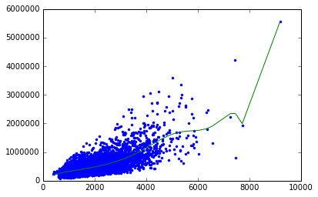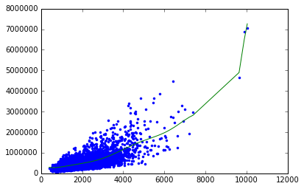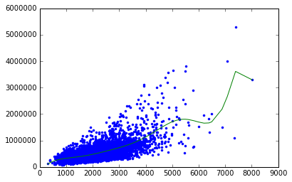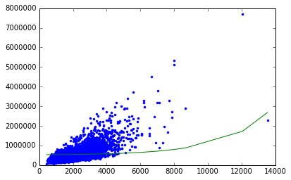
Ridge Regression comes to rescue:
Generally, whenever we see weights change so much in response to change in data, we believe the variance of our estimate to be large. Ridge regression aims to address this issue by penalizing "large" weights.
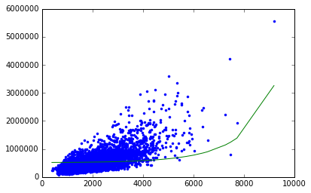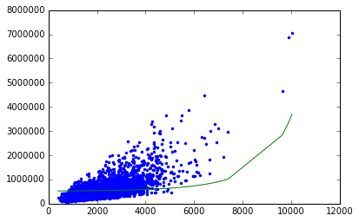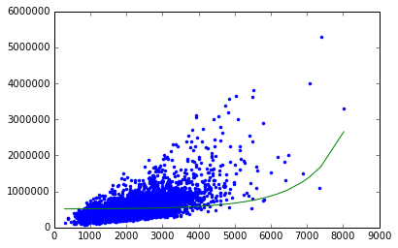
We refer to lambda in the Ridge case below as "L2 penalty"
Visualizing the effect of Ridge Regression: The L2 penalty gets its name because it causes weights to have small L2 norms than otherwise. Let's see how large weights get penalized. Let us consider a simple model with 1 feature:
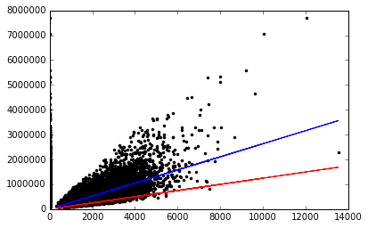

Explore the lasso solution as a function of a few different penalty strengths:
We refer to lambda in the lasso case below as "l1_penalty"
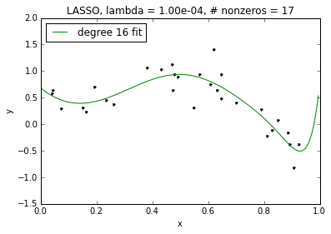
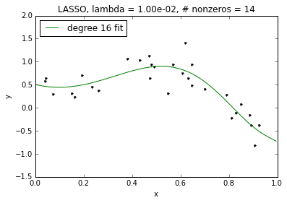
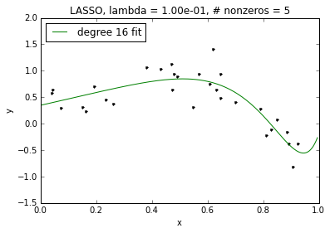
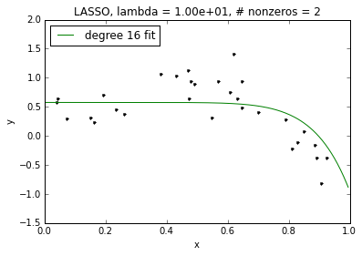
Above: We see that as lambda increases, we get sparser and sparser solutions. However, even for our non-sparse case for lambda=0.0001, the fit of our high-order polynomial is not too wild. This is because, like in ridge, coefficients included in the lasso solution are shrunk relative to those of the least squares (unregularized) solution. This leads to better behavior even without sparsity. Of course, as lambda goes to 0, the amount of this shrinkage decreases and the lasso solution approaches the (wild) least squares solution.
Example House with more features:

Observation: In this case, the model with more features provides a better prediction. This behavior is expected here, because this house is more differentiated by features that go beyond its square feet of living space, especially the fact that it's a waterfront house.
The model predicts a price of over $13M for this house! But we expect the house to cost much more. (There are very few samples in the dataset of houses that are this fancy, so we don't expect the model to capture a perfect prediction here.)

Document retrieval from Wikipedia data

Summary / Observations:
Tasks:
- Built Nearest Neighbor models with different input features and setting distance Metric
- Gained intuition for different notions of similarity and practice finding similar documents.
- Explored the trade-offs with representing documents using raw word counts and TF-IDF
- Explored the behavior of different distance metrics by looking at the Wikipedia pages most similar to President Obama’s page.
Visualizations:
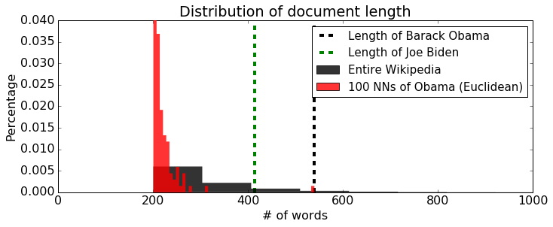
Relative to the rest of Wikipedia, nearest neighbors of Obama are overwhelmingly short, most of them being shorter than 300 words. The bias towards short articles is not appropriate in this application as there is really no reason to favor short articles over long articles (they are all Wikipedia articles, after all). Many of the Wikipedia articles are 300 words or more, and both Obama and Biden are over 300 words long.
Note: For the interest of computation time, the data set given here contains excerpts of the articles rather than full text. For instance, the actual Wikipedia article about Obama is around 25000 words. Do not be surprised by the low numbers shown in the histogram.
Note: Both word-count features and TF-IDF are proportional to word frequencies. While TF-IDF penalizes very common words, longer articles tend to have longer TF-IDF vectors simply because they have more words in them.
To remove this bias, we turn to cosine distances:
Cosine distances let us compare word distributions of two articles of varying lengths.
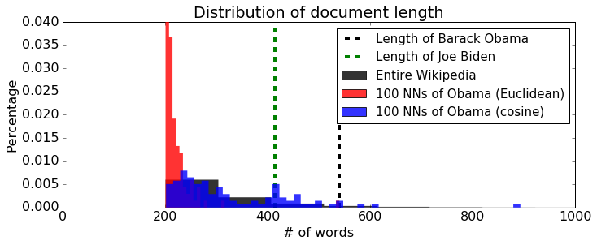
Indeed, the 100 nearest neighbors using cosine distance provide a sampling across the range of document lengths, rather than just short articles like Euclidean distance provided.
Moral of the story: In deciding the features and distance measures, check if they produce results that make sense for your particular application.

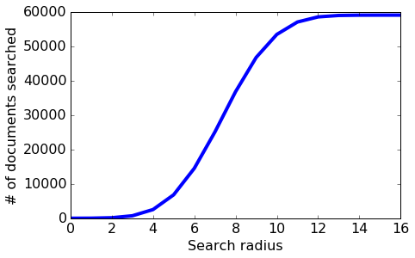
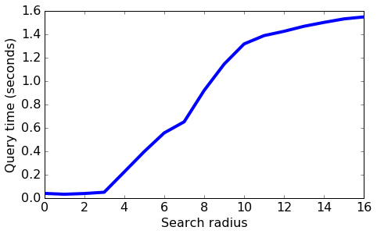
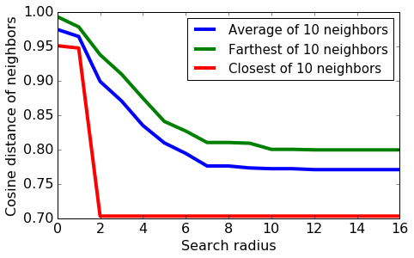
Some observations:
- As we increase the search radius, we find more neighbors that are a smaller distance away.
- With increased search radius comes a greater number documents that have to be searched. Query time is higher as a consequence.
- With sufficiently high search radius, the results of LSH begin to resemble the results of brute-force search.
Detailed Observations:
- Nearest neighbours with raw word counts got some things right, showing all politicians in the query result, but missed finer and important details.
- Much of the perceived commonalities between Obama and Barrio were due to occurrences of extremely frequent words, such as "the", "and", and "his". So nearest neighbours is recommending plausible results sometimes for the wrong reasons.
- To retrieve articles that are more relevant, we should focus more on rare words that don't happen in every article. TF-IDF (term frequency–inverse document frequency) is a feature representation that penalizes words that are too common. Let's use GraphLab Create's implementation of TF-IDF and repeat the search for the 10 nearest neighbours of Barack Obama:
- Noticed the huge difference in this calculation using TF-IDF scores instead of raw word counts. We've eliminated noise arising from extremely common words.
- Note: For the interest of computation time, the dataset given here contains excerpts of the articles rather than full text. For instance, the actual Wikipedia article about Obama is around 25000 words. Do not be surprised by the low numbers shown in the histogram.
- Note: Both word-count features and TF-IDF are proportional to word frequencies. While TF-IDF penalizes very common words, longer articles tend to have longer TF-IDF vectors simply because they have more words in them.
- To remove this bias, we turn to cosine distances:
- d(x,y)=1−xTy∥x∥∥y∥
  - Cosine distances let us compare word distributions of two articles of varying lengths.
  - Let us train a new nearest neighbour model, this time with cosine distances. We then repeat the search for Obama's 100 nearest neighbors.
- Moral of the story: In deciding the features and distance measures, check if they produce results that make sense for your particular application.
- Problem with cosine distances: tweets vs. long articles¶
- Happily, ever after? Not so fast. Cosine distances ignore all document lengths, which may be great in certain situations but not in others. For instance, consider the following (admittedly contrived) example.
  - How similar is this tweet to Barack Obama's Wikipedia article? Let's transform the tweet into TF-IDF features, using an encoder fit to the Wikipedia dataset. (That is, let's treat this tweet as an article in our Wikipedia dataset and see what happens.)
  - With cosine distances, the tweet is "nearer" to Barack Obama than everyone else, except for Joe Biden! This probably is not something we want. If someone is reading the Barack Obama Wikipedia page, would you want to recommend they read this tweet? Ignoring article lengths completely resulted in nonsensical results. In practice, it is common to enforce maximum or minimum document lengths. After all, when someone is reading a long article from The Atlantic, you wouldn't recommend him/her a tweet.
- Implementing Locality Sensitive Hashing from scratch - Locality Sensitive Hashing (LSH) provides for a fast, efficient approximate nearest neighbour search. The algorithm scales well with respect to the number of data points as well as dimensions.
Tasks:
- Implement the LSH algorithm for approximate nearest neighbour search
- Examine the accuracy for different documents by comparing against brute force search, and also contrast runtimes
- Explore the role of the algorithm’s tuning parameters in the accuracy of the method
Observations / Findings:
- Moral of the story: Similar data points will in general tend to fall into nearby bins, but that's all we can say about LSH. In a high-dimensional space such as text features, we often get unlucky with our selection of only a few random vectors such that dissimilar data points go into the same bin while similar data points fall into different bins. Given a query document, we must consider all documents in the nearby bins and sort them according to their actual distances from the query.
- Don't be surprised if few of the candidates look similar to Obama. This is why we add as many candidates as our computational budget allows and sort them by their distance to the query.

Experimenting with LSH implementation¶
- Implemented a few experiments to gain intuition for LSH implementation behaviour in different situations. This helped us understand the effect of searching nearby bins and the performance of LSH versus computing nearest neighbours using a brute force search.
- Effect of nearby bin search¶
- How does nearby bin search affect the outcome of LSH? There are three variables that are affected by the search radius:
  - Number of candidate documents considered
  - Query time
  - Distance of approximate neighbours from the query
- Let us run LSH multiple times, each with different radii for nearby bin search. We will measure the three variables as discussed above.
Observations:
- As we increase the search radius, we find more neighbours that are a smaller distance away.
- With increased search radius comes a greater number of documents that have to be searched. Query time is higher as a consequence.
- With sufficiently high search radius, the results of LSH begin to resemble the results of brute-force search.

· Quality metrics for neighbours¶
- The above analysis is limited by the fact that it was run with a single query, namely Barack Obama. We should repeat the analysis for the entirety of data. Iterating over all documents would take a long time, so let us randomly choose 10 documents for our analysis.
- For each document, we first compute the true 25 nearest neighbors, and then run LSH multiple times. We look at two metrics:
- Precision@10: How many of the 10 neighbors given by LSH are among the true 25 nearest neighbors?
- Average cosine distance of the neighbors from the query
- Then we run LSH multiple times with different search radii.
- We see a similar trade-off between quality and performance: as the number of random vectors increases, the query time goes down as each bin contains fewer documents on average, but on average the neighbours are likewise placed farther from the query. On the other hand, when using a small enough number of random vectors, LSH becomes very similar brute-force search: Many documents appear in a single bin, so searching the query bin alone covers a lot of the corpus; then, including neighbouring bins might result in searching all documents, just as in the brute-force approach.

· Clustering text data with Gaussian mixtures
- Used an EM implementation to fit a Gaussian mixture model with diagonalcovariances to a subset of the Wikipedia dataset.
- Takeaway - In this assignment we were able to apply the EM algorithm to a mixture of Gaussians model of text data. This was made possible by modifying the model to assume a diagonal covariance for each cluster, and by modifying the implementation to use a sparse matrix representation. In the second part, explored the role of k-means initialization on the convergence of the model as well as the interpretability of the clusters.

· Modeling text topics with Latent Dirichlet Allocation
In many cases, it is good to think of data as belonging to more than one cluster or category. For example, if we have a model for text data that includes both "Politics" and "World News" categories, then an article about a recent meeting of the United Nations should have membership in both categories rather than being forced into just one.
With this in mind, we will use GraphLab Create tools to fit an LDA model to a corpus of Wikipedia articles and examine the results to analyse the impact of a mixed membership approach.
Tasks:
- Applied standard pre-processing techniques on Wikipedia text data
- Used GraphLab Create to fit a Latent Dirichlet allocation (LDA) model
- Explored and interpreted the results, including topic keywords and topic assignments for a document
Objectives:
o To get the top words in each topic and use these to identify topic themes
o To predict topic distributions for some example documents
o To compare the quality of LDA "nearest neighbours" to the NN output from the first assignment
o To understand the role of model hyperparameters alpha and gamma

Observations:
- Noticed that that there is no overlap between the two sets of top 10 nearest neighbours. This doesn't necessarily mean that one representation is better or worse than the other, but rather that they are picking out different features of the documents.
- With TF-IDF, documents are distinguished by the frequency of uncommon words. Since similarity is defined based on the specific words used in the document, documents that are "close" under TF-IDF tend to be similar in terms of specific details. This is what we see in the example: the top 10 nearest neighbours are all economists from the US, UK, or Canada.
- Our LDA representation, on the other hand, defines similarity between documents in terms of their topic distributions. This means that documents can be "close" if they share similar themes, even though they may not share many of the same keywords. For the article on Paul Krugman, we expect the most important topics to be 'American college and politics' and 'science and research'. As a result, we see that the top 10 nearest neighbors are academics from a wide variety of fields, including literature, anthropology, and religious studies.
Changing the hyperparameter alpha - responsible for smoothing document preferences over topics
Observations:
Here we can clearly see the smoothing enforced by the alpha parameter - notice that when alpha is low most of the weight in the topic distribution for this article goes to a single topic, but when alpha is high the weight is much more evenly distributed across the topics.
Changing the hyperparameter gamma
Observations:
- From the two plots we can see that the low gamma model results in higher weight placed on the top words and lower weight placed on the bottom words for each topic, while the high gamma model places relatively less weight on the top words and more weight on the bottom words. Thus, increasing gamma results in topics that have a smoother distribution of weight across all the words in the vocabulary.
Summary Observations:
- We have now seen how the hyperparameters alpha and gamma influence the characteristics of our LDA topic model, but we haven't said anything about what settings of alpha or gamma are best. We know that these parameters are responsible for controlling the smoothness of the topic distributions for documents and word distributions for topics, but there's no simple conversion between smoothness of these distributions and quality of the topic model. In reality, there is no universally "best" choice for these parameters. Instead, finding a good topic model requires that we be able to both explore the output (as we did by looking at the topics and checking some topic predictions for documents) and understand the impact of hyperparameter settings (as we have in this section).

· Modeling text data with a hierarchy of clusters
Hierarchical clustering refers to a class of clustering methods that seek to build a hierarchy of clusters, in which some clusters contain others. Explored a top-down approach, recursively partitioning the data using k-means.
Observations:
- We might want to build a directory for Wikipedia articles. A good directory would let you quickly narrow down your search to a small set of related articles. The categories of athletes and non-athletes are too general to facilitate efficient search. For this reason, we decide to build another level into our hierarchy of clusters with the goal of getting more specific cluster structure at the lower level. To that end, we subdivide both the athletes and non-athletes ‘clusters.
- Perform recursive bipartitioning
- Should we keep subdividing the clusters? If so, which cluster should we subdivide? To answer this question, we again think about our application. Since we organize our directory by topics, it would be nice to have topics that are about as coarse as each other. For instance, if one cluster is about baseball, we expect some other clusters about football, basketball, volleyball, and so forth. That is, we would like to achieve similar level of granularity for all clusters.
- Notice that the right child cluster is coarser than the left child cluster. The right cluster possesses a greater variety of topics than the left (ice hockey/association football l/ Australian football vs. baseball). So the right child cluster should be subdivided further to produce finer child clusters.

Observations:
- If a cluster is highly mixed, the top articles and words may not convey the full picture of the cluster. Thus, we may be misled if we judge the purity of clusters solely by their top documents and words.
- Many interesting topics are hidden somewhere inside the clusters but do not appear in the visualization. We may need to subdivide further to discover new topics. For instance, subdividing the ice_hockey_football cluster led to the appearance of runners and golfers.

Recommending Songs:

Summary / Observations:
- Loaded and transformed real, song data.
- Built a song recommend er model and explored the song data and the recommendations made by our model.
- Used the model to recommend songs to individual users.
- Used group by [data manipulation primitives] to compute aggregate statistics of the data.
- Learnt how to use one of the most important data manipulation primitives, group by.
- Computed the number of unique users who have listened to songs by various artists.
- Used group by-aggregate to find the most popular and least popular artist.
- Used group by-aggregate to find the most recommended songs. Computed recommendations for first 10,000 users.
Most Recommended Songs:
song | count
Undo - Björk | 438
Secrets - OneRepublic | 390
Revelry - Kings Of Leon | 225
You're The One - Dwight  Yoakam ... | 164
Fireflies - Charttraxx  Karaoke ... | 124
Sehr kosmisch - Harmonia | 98
Horn Concerto No. 4 in E  flat K495: II. Romance ... | 94
Hey_ Soul Sister - Train | 73
OMG - Usher featuring  will.i.am ... | 63
Dog Days Are Over (Radio  Edit) - Florence + The ... | 46

Deep features for Image retrieval nearest neighbour search

Summary / Observations:
Fitting a Gaussian mixture model for image data and cluster the same type of images.
Tasks:
- Applied the implementation of the EM [Expectation Maximization] algorithm, to cluster some more interesting data. In particular, we have a set of images that come from four categories: sunsets, rivers, trees and forests, and cloudy skies. For each image we are given the average intensity of its red, green, and blue pixels, so we have a 3-dimensional representation of our data. Our goal is to find a good clustering of these images using our EM implementation; ideally our algorithm would find clusters that roughly correspond to the four image categories.
- Explored clustering results and interpret the output of the EM algorithm
- Like k-means, EM is prone to converging to a local optimum. In practice, you may want to run EM multiple times with different random initialization.
- Observations: The results looked pretty good! Our algorithm seems to have done a good job overall at 'discovering' the four categories that from which our image data was drawn. It seems to have had the most difficulty in distinguishing between rivers and cloudy skies, probably due to the similar colour profiles of images in these categories; if we wanted to achieve better performance on distinguishing between these categories, we might need a richer representation of our data than simply the average [R G B] values for each image.
Visualizations:
We'll apply EM algorithm to cluster some more interesting data. In particular, we have a set of images that come from four categories: sunsets, rivers, trees and forests, and cloudy skies. For each image we are given the average intensity of its red, green, and blue pixels, so we have a 3-dimensional representation of our data. Our goal is to find a good clustering of these images using our EM implementation; ideally our algorithm would find clusters that roughly correspond to the four image categories.
The following sections will evaluate the results by asking the following questions:
- Convergence: How did the log likelihood change across iterations? Did the algorithm achieve convergence?
- Uncertainty: How did cluster assignment and uncertainty evolve?
- Interpretability: Can we view some example images from each cluster? Do these clusters correspond to known image categories?
Evaluating convergence:
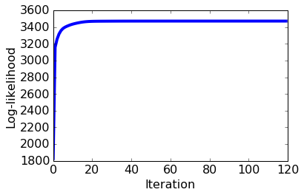
The log likelihood increases so quickly on the first few iterations that we can barely see the plotted line. Let's plot the log likelihood after the first three iterations to get a clearer view of what's going on:
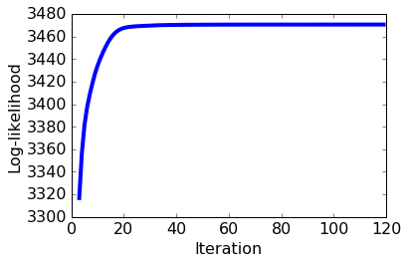
Evaluating Uncertainty:
To begin, we will visualize what happens when each data has random responsibilities.

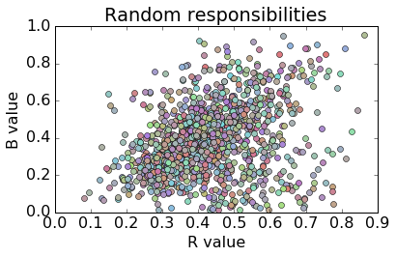
We now use the above plotting function to visualize the responsibilities after 1 iteration.

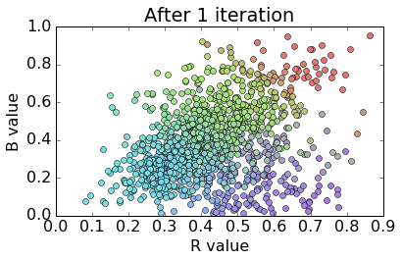
We now use the above plotting function to visualize the responsibilites after 20 iterations. We will see there are fewer unique colors; this indicates that there is more certainty that each point belongs to one of the four components in the model.

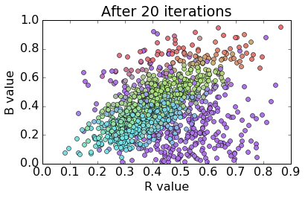

Plotting the responsibilities over time in [R B] space shows a meaningful change in cluster assignments over the course of the algorithm's execution. While the clusters look significantly better organized at the end of the algorithm than they did at the start, it appears from our plot that they are still not very well separated. We note that this is due in part our decision to plot 3D data in a 2D space; everything that was separated along the G axis is now "squashed" down onto the flat [R B] plane. If we were to plot the data in full [R G B] space, then we would expect to see further separation of the final clusters. We'll explore the cluster interpretability more in the next section.

Interpreting each cluster:
Let's dig into the clusters obtained from our EM implementation. Recall that our goal in this section is to cluster images based on their RGB values. We can evaluate the quality of our clustering by taking a look at a few images that 'belong' to each cluster. We hope to find that the clusters discovered by our EM algorithm correspond to different image categories - in this case, we know that our images came from four categories ('cloudy sky', 'rivers', 'sunsets', and 'trees and forests'), so we would expect to find that each component of our fitted mixture model roughly corresponds to one of these categories.

All Clouds in one Cluster:

[gallery ids="139,140,141,142,143" type="columns"]

All Rivers in one Cluster:

[gallery ids="144,145,146,147,148" type="columns"]

All trees in one Cluster:

[gallery ids="149,150,151,152,153" type="columns"]

All sunsets in one cluster

[gallery ids="154,155,156,157,158" type="columns"]
These look pretty good! Our algorithm seems to have done a good job overall at 'discovering' the four categories that from which our image data was drawn. It seems to have had the most difficulty in distinguishing between rivers and cloudy skies, probably due to the similar color profiles of images in these categories; if we wanted to achieve better performance on distinguishing between these categories, we might need a richer representation of our data than simply the average [R G B] values for each image.

Predicting sentiment from product reviews

Summary / Observations:
Tasks:
- Used product review data from Amazon.com to predict whether the sentiments about a product (from its reviews) are positive or negative. Built a song recommend-er model and explored the song data and the recommendations made by our model.
- Trained a logistic regression model.
- Explore various evaluation metrics: accuracy, confusion matrix, precision, recall.
- Explore how various metrics can be combined to produce a cost of making an error.
- Explore precision and recall curves
- Explore various different values of thresholds, compute the precision and recall scores, and then plot the precision-recall curve.
Observations:
- The precision increase with a higher threshold
- The recall decreases with a higher threshold
- Among all the threshold values tried, identified the smallest threshold value that achieves a precision of 96.5% or better
- Using threshold = 0.98, identified how many false negatives do we get on the test data
- Trained Logistic regression classifier using stochastic gradient ascent.
Tasks:
- Extracted features from Amazon product reviews.
- Implemented stochastic gradient ascent with L2 penalty
- Compared convergence of stochastic gradient ascent with that of batch gradient ascent
- Explored the effects of step sizes on stochastic gradient ascent
Observations:
- When we set the batch size as the length of the feature matrix in training data, as each iteration passes, the average log likelihood in the batch increases

Amazon Sentiment Review Analysis:
In each of the following models, the following parameters are used for tuning using cross-
validation and the final accuracy is calculated.
1) Decision Tree Classification:
The decision tree implementation in Assignment 1 obtained its best accuracy, after pruning
the decision tree with a maximum depth of 10 on the Amazon Review dataset.
The training accuracy obtained is: 88.5% and Testing Accuracy obtained is: 83.9%
2) Neural Network Classification:
The Neural Network implementation in Assignment 2 obtained a best accuracy by setting
the following parameters: iterations = 500, number of hidden layers = 600, Activation
function = RELU, Solver = SGD, Learning Rate = 0.001, Regularization Parameter alpha-
0.0001.
The above settings gave a training accuracy of 91.81% and Testing accuracy of 73.89%
3) K-Nearest Neighbors Classification Model:
For K-Nearest Neighbor classification model, after hyperparameter tuning of K, the value of
K =6 gives more accuracy on the Testing dataset. Hence, K = 6 is considered as the tuned
parameter. Hence it obtained an accuracy of 86.62% on the Training dataset, 85.31% on the
testing dataset. (Reference Assignment 3)
4) Adaboosting Classification model:
After tuning the parameters of the n_estimators, the value n_estimator=900 gives a better
accuracy which reduces the error on both the training as well as a testing dataset.
The above settings gave an accuracy of 94.63% on the training dataset, 74.66% on the
testing dataset.
5) SVM Classification Model:
For the Support Vector Machine Classification model, the values gamma, C are tuned and
comparison of various kernels is done. After tuning, the Poly Kernel seems to be the best fit
and the degree used is 3.
The above parameters on the SVM Classification model gave an accuracy of 85.54% on the
Training dataset, 85.53% on the testing dataset.
6) Naïve Bayes Classification Model:
For the Naïve Bayes classification model, the priors are not needed to train the learning
model. The Laplacian smoothing of 1.0 is applied to the Training dataset to estimate the
value. The Multinomial NB gave a better training accuracy of 87.6% and a testing accuracy
of 82.79%.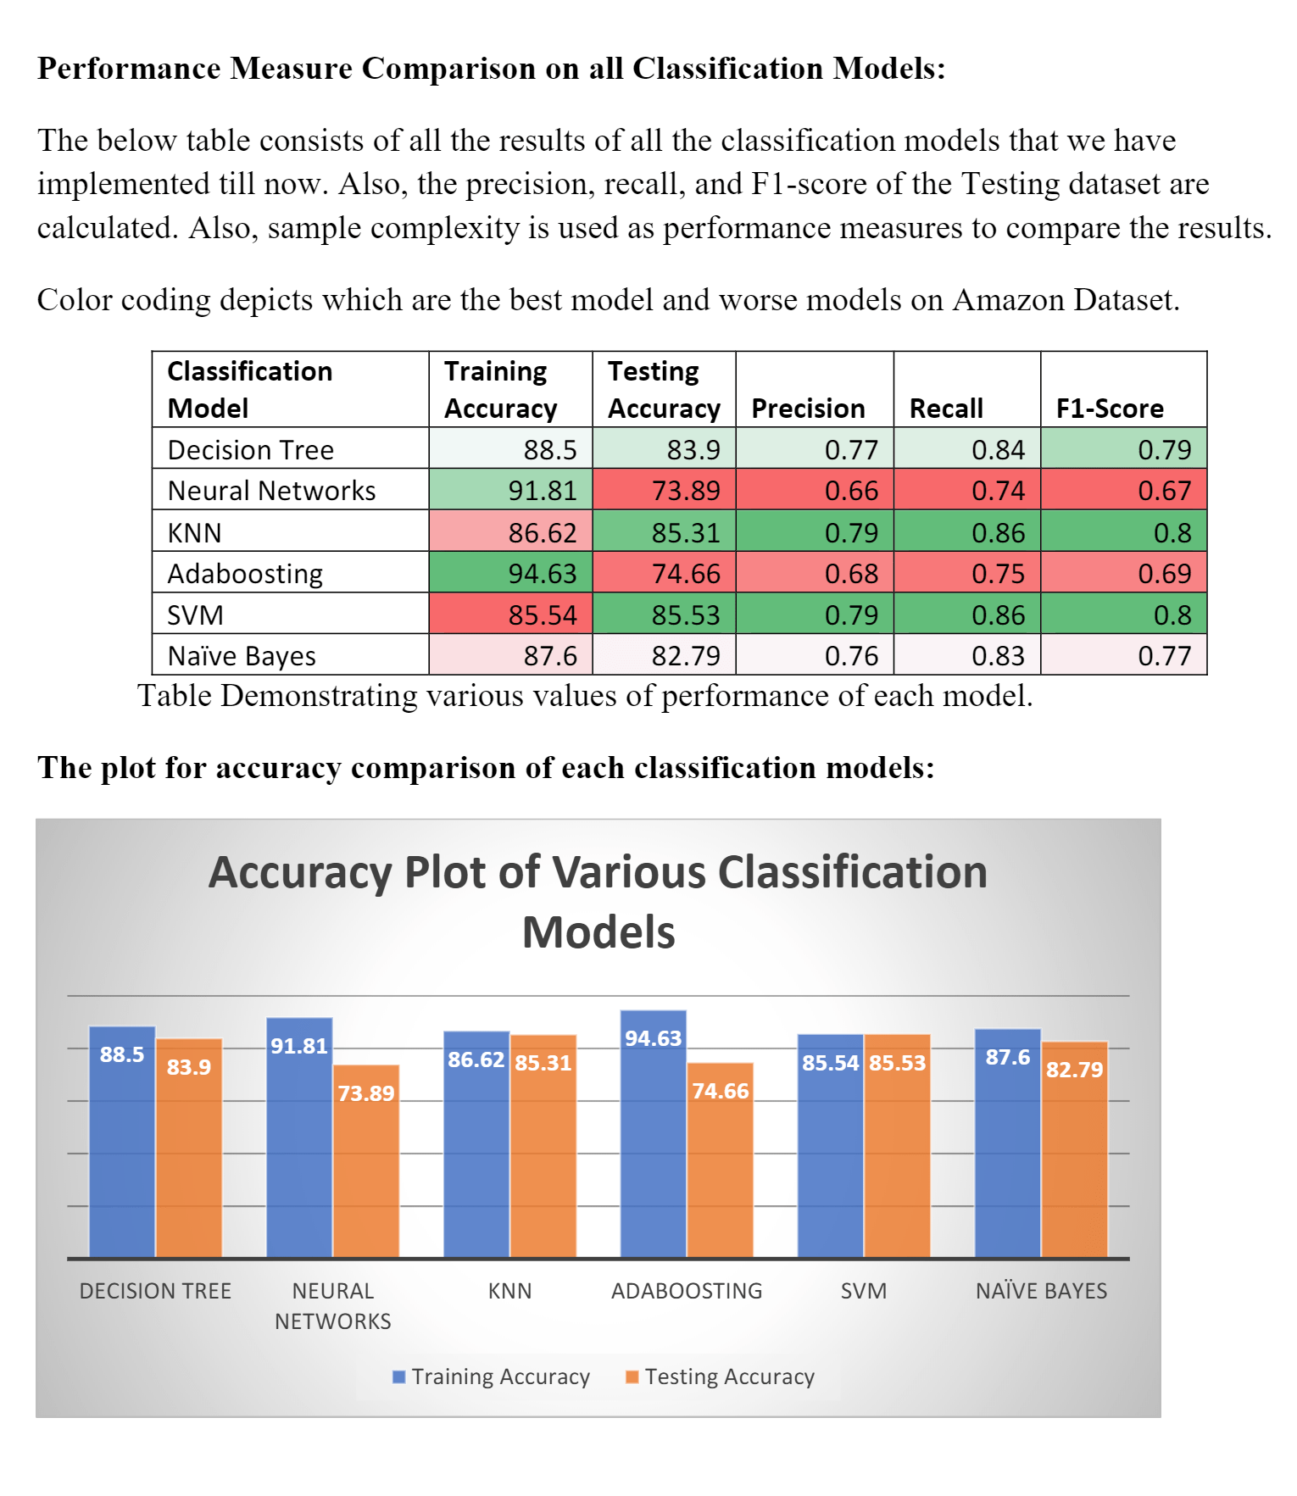
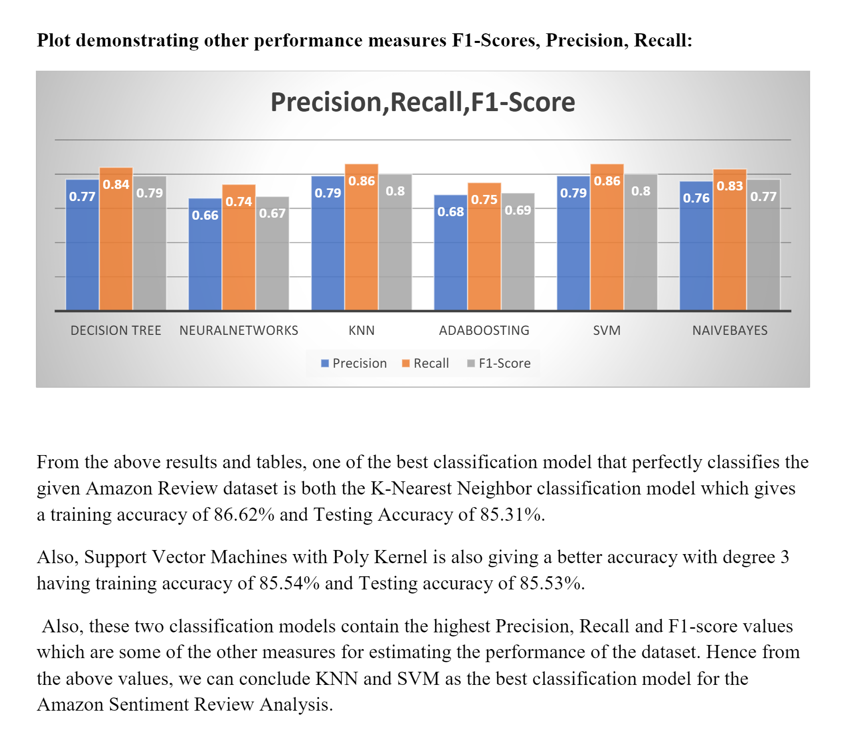
From the above results and tables, one of the best classification model that perfectly classifies the
given Amazon Review dataset is both the K-Nearest Neighbor classification model which gives
a training accuracy of 86.62% and Testing Accuracy of 85.31%.
Also, Support Vector Machines with Poly Kernel is also giving a better accuracy with degree 3
having training accuracy of 85.54% and Testing accuracy of 85.53%.
Also, these two classification models contain the highest Precision, Recall and F1-score values
which are some of the other measures for estimating the performance of the dataset. Hence from
the above values, we can conclude KNN and SVM as the best classification model for the
Amazon Sentiment Review Analysis.

Identifying safe loans with decision trees

Summary / Observations:
The Lending Club is a peer-to-peer leading company that directly connects borrowers and potential lenders/investors. Built a classification model to predict whether or not a loan provided by Lending Club is likely to default.
Tasks:

- Used data from the Lending Club to predict whether a loan will be paid off in full or the loan will be charged off and possibly go into default.
- Used SFrames to do some feature engineering.
- Trained a decision-tree on the Lending Club dataset.
- Visualized the tree.
- Predicted whether a loan will default along with prediction probabilities (on a validation set).
- Trained a complex tree model and compare it to simple tree model.

Visualizations:
Visualizing the prediction on a tree by traversing a point from the sample validation data and visualize the prediction being made.
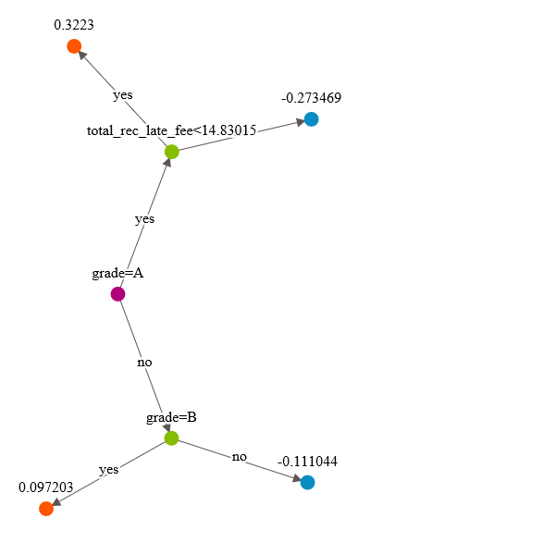
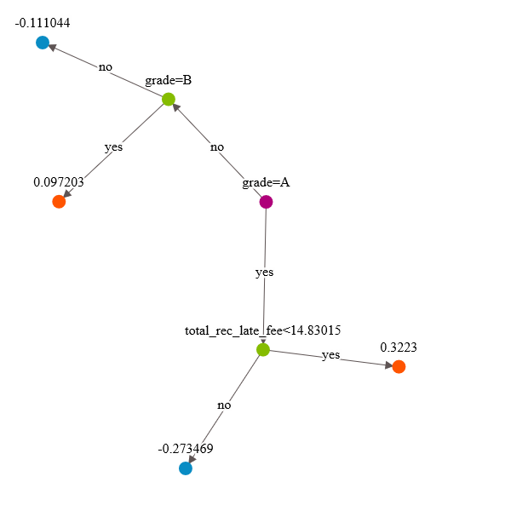
Note: In the tree visualization above, the values at the leaf nodes are not class predictions but scores.If the score is ≥ 0, the class +1 is predicted. Otherwise, if the score < 0, we predict class -1.
Evaluation of Decision Tree Model
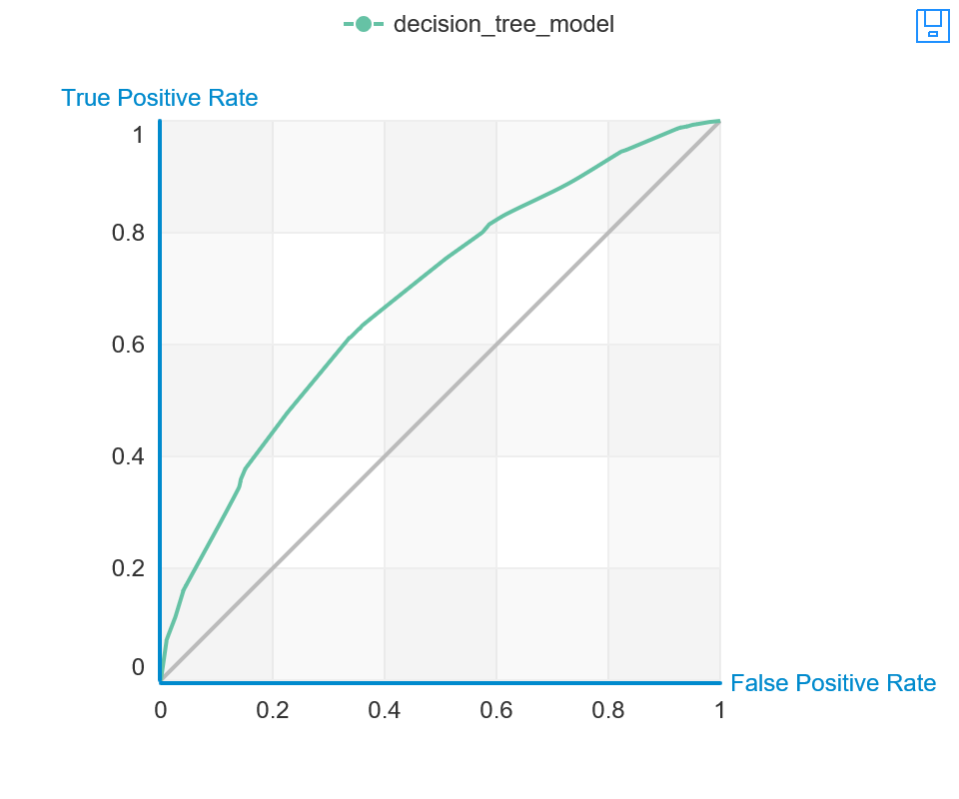
True Positive | False Negative | Accuracy | Precision
0 | 4610 | 0.503 | NaN
False Positive | True Negative | Recall | F1 Score
0 | 4674 | 0 | 0

Threshold
0.668

AUC
0.685

General Metrics
f1_score | 0.632
auc | 0.684
recall | 0.628
precision | 0.636
log_loss | 0.665
accuracy | 0.637
- Assume a cost of $10,000 per false negative.
- Assume a cost of $20,000 per false positive.
Findings: The total cost of mistakes made by decision_tree_model on validation_data
No. of Mistakes: 1716
Total Cost of Mistakes: 50280000
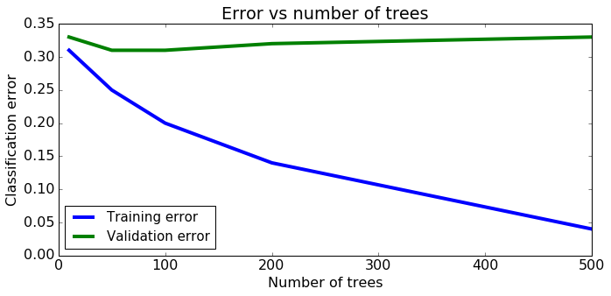
The training error reduce as the number of trees increases.
The validation error will not reduce as the number of trees increases.
Observations:
- Sampled data to balance classes, as our data is disproportionally Note:
- Manage Imbalanced data -There are many approaches for dealing with imbalanced data, including some where we modify the learning algorithm. Used the simplest possible approach, where we subsample the overly represented class to get a more balanced dataset. In general, and especially when the data is highly imbalanced, it is recommended to use more advanced methods.
- The portion of data that we don't train on will be used to help select model parameters (this is known as model selection). Thus, this portion of data should be called a validation set. Recall that examining performance of various potential models (i.e. models with different parameters) should be on validation set, while evaluation of the final selected model should always be on test data.
- Quantifying the cost of mistakes¶-Every mistake the model makes costs money. In this section, we will try and quantify the cost of each mistake made by the model.
- Assume the following:
- False negatives: Loans that were actually safe but were predicted to be risky. This results in an opportunity cost of losing a loan that would have otherwise been accepted.
- False positives: Loans that were actually risky but were predicted to be safe. These are much more expensive because it results in a risky loan being given.
- Correct predictions: All correct predictions don't typically incur any cost.
Implementing binary decision trees
- The goal of this assignment is to implement our own binary decision tree classifier.
- Used SFrames to do some feature engineering.
- Transformed categorical variables into binary variables.
- Built a binary decision tree from scratch.
- Made predictions using the decision tree.
- Evaluated the accuracy of the decision tree.
- Visualized the decision at the root node.
- Important Note: In this assignment, we will focus on building decision trees where the data contain only binary (0 or 1) features. This allows us to avoid dealing with:
- Multiple intermediate nodes in a split
- The thresholding issues of real-valued features.
Decision Trees in Practice
- Implement binary decision trees with different early stopping methods.
- Compared models with different stopping parameters.
- Visualized the concept of overfitting in decision trees.
Gradient boosted tree classifier
Tasks:
- Explored Ensemble Methods
- Explored the use of boosting.
- Used the pre-implemented gradient boosted trees in Graphlab-Create.
- Used SFrames to do some feature engineering.
- Trained a boosted ensemble of decision-trees (gradient boosted trees) on the lending club dataset.
- Predicted whether a loan will default along with prediction probabilities (on a validation set).
- Evaluated the trained model and compare it with a baseline.
- Found the most positive and negative loans using the learned model.
- Explored how the number of trees influences classification performance.
- Plotted the training and validation error vs. number of trees
Observations:
- In the earlier assignment, we saw that the prediction accuracy of the decision trees was around 0.64 (rounded). In this assignment, we saw that model_5 has an accuracy of 0.67 (rounded).
- Here, we quantify the benefit of the extra 3% increase in accuracy of model_5 in comparison with a single decision tree from the original decision tree assignment.
- Reminder: Compare the cost of the mistakes made by the boosted trees model with the decision tree model. The extra 3% improvement in prediction accuracy can translate to several million dollars! And, it was so easy to get by simply boosting our decision trees.
Boosting a decision stump
Tasks:
- Implement our own boosting module. A fun and challenging assignment.
- Used SFrames to do some feature engineering.
- Trained a boosted ensemble of decision-trees (gradient boosted trees) on the lending club dataset.
- Predicted whether a loan will default along with prediction probabilities (on a validation set).
- Evaluated the trained model and compare it with a baseline.
- Found the most positive and negative loans using the learned model.
- Explored how the number of trees influences classification performance.
Observations:
- The model small_data_decision_tree_subset_20 performs a lot better on subset_20 than on train_data which means - The points with higher weights are the ones that are more important during the training process of the weighted decision tree.
- The points with zero weights are basically ignored during training.
- Stump weights (ŵ ) and data point weights (α) are two different concepts. Stump weights (ŵ ) tell us how important each stump is while making predictions with the entire boosted ensemble.
- Data point weights (α) tell us how important each data point is while training a decision stump.

Modeling and clustering text data with K-means

Summary / Observations:

Clustering text data with k-means
- Clustered Wikipedia documents using k-means
- Explored the role of random initialization on the quality of the clustering
- Explored how results differ after changing the number of clusters
- Evaluated clustering, both quantitatively and qualitatively
- When properly executed, clustering uncovers valuable insights from a set of unlabeled documents.
Visualizations:
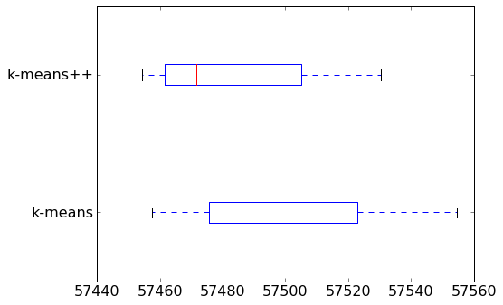
A few things to notice from the box plot:
- On average, k-means++ produces a better clustering than Random initialization.
- Variation in clustering quality is smaller for k-means++.
In general, you should run k-means at least a few times with different initializations and then return the run resulting in the lowest heterogeneity.
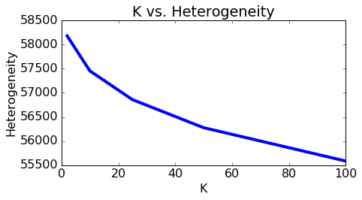
In the above plot we show that heterogeneity goes down as we increase the number of clusters. Does this mean we should always favor a higher K? Not at all! As we will see in the following section, setting K too high may end up separating data points that are actually pretty alike. At the extreme, we can set individual data points to be their own clusters (K=N) and achieve zero heterogeneity, but separating each data point into its own cluster is hardly a desirable outcome. In the following section, we will learn how to detect a K set "too large".
Fitting a mixture of Gaussians using Expectation Maximization Algorithm:
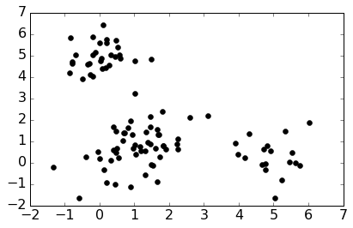
Now we'll fit a mixture of Gaussians to this data using our implementation of the EM algorithm. In this simple case, we'll take three random points to be the initial cluster means, use the empirical covariance of the data to be the initial covariance in each cluster (a clear overestimate), and set the initial mixing weights to be uniform across clusters.
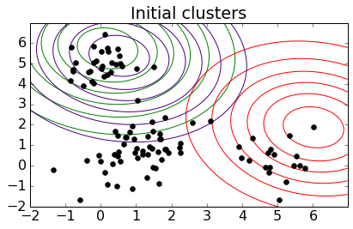
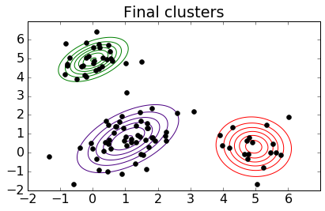
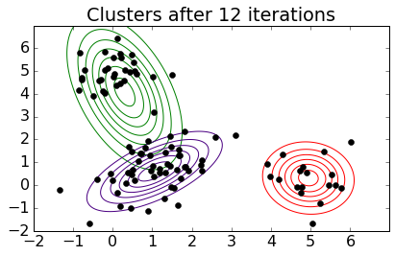
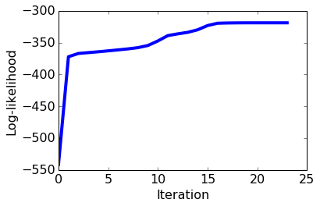
Note: Loglikelihood plot monotonically increasing
Observations:
One weakness of k-means is that it tends to get stuck in a local minimum. To see this, we run k-means multiple times, with different initial centroids created using different random seeds.
Notice the variation in heterogeneity for different initializations. This indicates that k-means sometimes gets stuck at a bad local minimum.
One effective way to counter this tendency is to use k-means++ to provide a smart initialization. This method tries to spread out the initial set of centroids so that they are not too close together. It is known to improve the quality of local optima and lower average runtime.
A few things to notice from the box plot:
On average, k-means++ produces a better clustering than Random initialization.
Variation in clustering quality is smaller for k-means++.
In general, we should run k-means at least a few times with different initializations and then return the run resulting in the lowest heterogeneity.
To Choose k - Since we are measuring the tightness of the clusters, a higher value of K reduces the possible heterogeneity metric by definition. For example, if we have N data points and set K=N clusters, then we could have 0 cluster heterogeneity by setting the N centroids equal to the values of the N data points.
Visualize clusters of documents
What are we looking for in a good clustering of documents?
Documents in the same cluster should be similar.
Documents from different clusters should be less similar.
So, a bad clustering exhibits either of two symptoms:
Documents in a cluster have mixed content.
Documents with similar content are divided up and put into different clusters.
Takeaway: Tiny clusters aren't necessarily bad. A tiny cluster of documents that really look like each other’s is definitely preferable to a medium-sized cluster of documents with mixed content. However, having too few articles in a cluster may cause overfitting by reading too much into a limited pool of training data.

Clustering and measuring similarity:
Document retrieval Task: There are lots and lots of articles out there and we can't expect him to go and read each of them and say yes, he's interested or no, he's not. So, we like to think of a way to automatically retrieve a document that might be of interest to him.
Types of Models for document representation:
Bag of words Model:
Ignore Order of Words
Count No. of Instances of each word in Vocabulary [Count Vector]
To measure similarity: when we think about measuring similarity, what we can do is simply look at an element-wise product over this vector. So, for every element in the vector, we're going to multiply the two elements appearing in these two different count vectors. And add up over all the different elements in this vector.
Discovering similar neighbourhoods –
Task1- Came up with a good estimate of the house in the neighbourhood with few or no sales by leveraging information from this other neighbourhood that was discovered to be related to the current neighbourhood. So, the idea is to discover clusters of neighbourhoods, and then within those clusters we can share information like this house sales information to form better estimates. So, this is the solution that I'm describing here, is to cluster regions with similar trends, and then share information within a cluster.

Task2- Same idea of discovering related regions can be used for helping to forecast violent crimes, to better task police forces to different regions. So again, once we discover different neighbourhoods that have very similar crime dynamics, we can form better predictions of the rates of violent crimes in those neighbourhoods and then use that information to task police to those regions.

